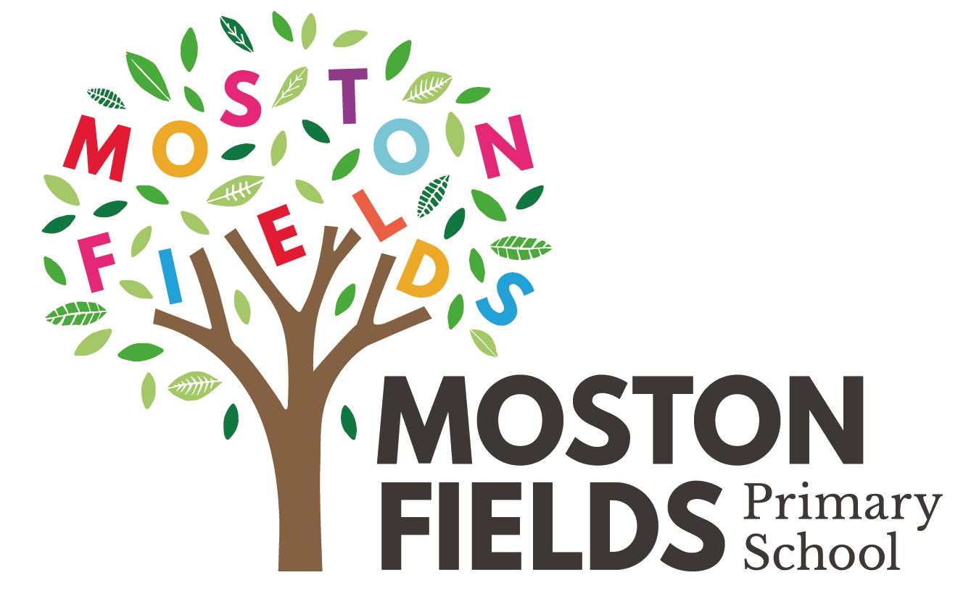
Relationships and Healthy Lifestyles Policy
(based upon the statutory delivery of Relationships and and Health Education DfE Guidance June 2019)

Approved by: | [Name] | Date: [Date]
Last reviewed on: | [Date]
Next review due by: | [Date]

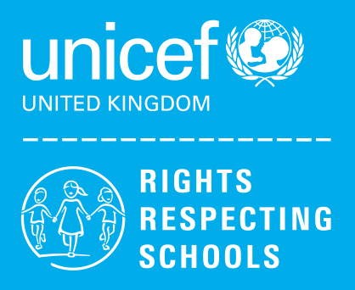
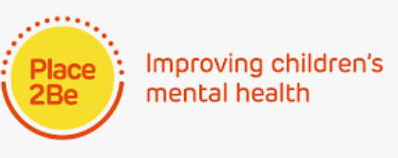

Contents
1. Aims 3
2. Statutory requirements 3
3. Policy development 4
4. Definition 4
5. Curriculum 5
6. Delivery of RSE 5
7. Roles and responsibilities 6
8. Parents’ right to withdraw 7
9. Training 7
10. Monitoring arrangements 7
Appendix 1: Curriculum map 8
Appendix 2: By the end of primary school children should know 9
Appendix 2: By the end of secondary school children should know 11
Appendix 3: Parent form: withdrawal from sex education in RSE 14

How this policy fits in with our school values
At Moston Fields it is our mission to grow lifelong learners in all aspects of the curriculum and in preparation for children becoming active and respectful citizens of the future. To do this, it is vital for children to learn to navigate the challenges that they may encounter in their relationships, lifestyle choices and interactions within an ever changing world. We believe that explicitly teaching children to know and care for themselves and others is vital to living a mentally and physically healthy life.
As a Rights Respecting school, we are committed to providing children with age-appropriate factual information and scenarios that will aid this. In this way, delivering the statutory content of the Relationships and Health Guidance (including Sex Education) from the Department for Education fits in with our curriculum approach. Through this policy we will ensure that we review content and approach to reflect the needs of our community, whilst recognising the important place of education in shaping children to recognise that a peaceful civilisation needs tolerance, equality and liberty to be respected by all.

1. Aims
The aims of delivering the statutory relationships and sex education (RSE)curriculum at our school are to:
Citizenship/community
- Give children the skills and knowledge to safeguard themselves within their relationships, lifestyle choices and as a member of a community
- Provide a framework of teaching the Rights of the Child to build knowledge and understanding to inform choices and behaviours
- Promote the value of recognising their place in the community through active citizenship
- Provide opportunities for developing life skills that support key elements of the curriculum such as safety, first aid and citizenship
- Promote the British Values of Individual Liberty, Democracy, Mutual Respect and Tolerance and Rule of Law

Relationships and Sex Education
- Provide a framework in which sensitive discussions about differences and the protective factors can take place
- Prepare children for puberty, and give them an understanding of sexual development and the importance of health and hygiene in an age appropriate way
- Teach children the correct vocabulary to describe themselves and their bodies in an age appropriate way

Safe Relationships and social behaviours
- Give children the knowledge and skills in how to respect safe and healthy boundaries in their life and to know how to make themselves heard if they feel unsafe
- Help children to develop feelings of self-respect, confidence and empathy for themselves and within their relationships
- Create a positive culture around differences of sexuality and relationships in and outside the family

Healthy Lifestyles and Mental Health
- Provide children with the skills and knowledge to protect themselves online and within online communities (age appropriately)
- Prepare children to live healthy lifestyles and to have an ongoing awareness of being healthy
- Develop an understanding of the importance of mental health and well-being
- Teach children to develop strategies to support their own mental health and well-being

2. Statutory requirements

As a maintained primary school we must provide relationships education to all children as per section 34 of the Children and Social work act 2017.
However, we are not statutorily required to provide sex education but we do need to teach the elements of sex education contained in the science curriculum, which includes the lifecycle of plants and animals, an understanding of how our body works and elements of Growing and Changing that affect us as we grow, e.g. changes to our bodies in puberty and why they happen.
As a school we have chosen not to teach the non-statutory elements of Sex Education such as how a baby is conceived and born.
In teaching RSE, we must have regard to guidance issued by the secretary of state as outlined in section 403 of the Education Act 1996.
At Moston Fields Primary School we will teach RSE as set out in this policy.

3. Policy development
This policy has been developed in consultation with staff, children and parents. The consultation and policy development process involved the following steps:
- Review – a member of staff or working group pulled together all relevant information including relevant national and local guidance

- Staff consultation – all school staff were given the opportunity to look at the policy and make recommendations

- Parent/stakeholder consultation – parents and any interested parties were invited to attend a meeting about the policy

- Pupil consultation – we investigated what exactly children want from their RSE

- Ratification – once amendments were made, the policy was shared with governors and ratified

4. Definition
Our Relationships and Healthy Lifestyles curriculum is about the physical, emotional, social and cultural development of children, and involves learning about respectful relationships, including different types of families, puberty (Growing and Changing), healthy lifestyles, equality, diversity and personal identity.
Our Relationships and Healthy Lifestyles curriculum involves a combination of sharing information and exploring issues and values.

5. Curriculum
Our curriculum is set out as per Appendix 1, but we may need to adapt it as and when necessary.
Our Relationships and Healthy LIfestyles Curriculum is a bespoke curriculum based upon the statutory elements of RSE and includes the use of resources from the following programmes and providers:
No Outsider/Agents of Hope (Andrew Moffat) Learning for Peace (Peacemakers) Zones of Regulation, the Commando Joe’s Respect curriculum, Stonewall, Place2Be,UNICEF resources and the Manchester Healthy Schools iMatter curriculum.
We have developed the curriculum in consultation with parents, children and staff, taking into account the age, needs and feelings of children and the community. The approach to delivering this curriculum aligns with developing children as lifelong learners and preparing them for leading healthy lives. Topics will be dealt with sensitively and children will be encouraged to ask questions to deepen their understanding.
If children ask questions in relation to Sex Education, outside the scope of this policy, teachers will respond in a sensitive but age appropriate manner in line with our science curriculum. Where questions go beyond this, parents will be informed in order for them to respond in line with their family values. Teachers will advise or signpost, where needed. Our Family Liaison Worker will also be available to support families with guidance on how best to approach this situation.
If parents would like further information about the resources that we use, please use the following links:

Include resource references.

For more information about our curriculum, see our curriculum map in Appendix 1.

6. Delivery of RSE
Relationships and Healthy Lifestyle Curriculum is taught within the personal, social, and health (PSHE) education curriculum. Biological aspects of this curriculum are also taught within the science curriculum, and other moral aspects are included in religious education (RE).
The approach to delivery of this curriculum sits within the whole school ethos of developing children as lifelong learners. It is also underpinned by our Rights Respecting approach. To learn and grow in their relationships, children need to learn how to get along, how to appreciate differences and what a healthy lifestyle is; physically and mentally. The themes within the curriculum will be promoted in assemblies and the use of Big Questions. Every opportunity to nurture positive relationships and behaviours will be taken through a restorative approach to developing positive behaviours and engaging children in reflections on their own choices. This links with the School’s Rights Respecting Behaviour Policy and approach.
The teaching of Relationships and Healthy Lifestyles will ensure that children are taught not to discriminate against the protected characteristics as enshrined in law through the Equality Act 2010: :
- age
- disability
- gender reassignment
- marriage and civil partnership
- pregnancy and maternity
- race
- religion or belief
- sex

How the lessons will be delivered
Lessons will be delivered in a variety of ways:
- Circle times - Allowing children to explore issues through role play and games as well as providing a safe place for conversation
- Through the use of picture books – these will provide follow up activities that support the context of the book, allowing for discussion and exploration of topics such as diversity, varied life experiences, gender etc.
- Commando Joe’s missions are delivered to provide children with the opportunity to develop the skills of Resilience, Empathy, Self Awareness, Passion, Excellence, Communication and Team Work.
- Zones of Regulation will be taught to identify feelings and emotions, learning different techniques for regulating emotions and behaviours inside and outside of school
- Rights in the curriculum and our class charters
PSHE will be linked to ILPs, where there are clear links throughout the project for example in Year 6 when studying Blood Heart ILP, children will explore gender equality, aspects of PSHE and the moral ethics of transplants. Another example is in Year 1 when studying Memory Box, children will explore playing cooperatively, feelings of positivity and caring for others.
Children will also receive stand-alone Growing and Changing sessions, where possible, delivered by a trained health professional. This will take place in Years 4-6, with early elements of this curriculum being taught in Years 1-3, including families, healthy relationships and understanding of personal space. children will be taught in mixed groups although this may be altered to meet the needs of the class.
In Years 4-6, children will learn about the physical and emotional changes in their bodies as they get older and parents will be informed when these lessons will take place in the year. Parents will also be given signposting for advice in order to support any questions at home.
Healthy Lifestyles will also be promoted and taught through PE lessons, the science curriculum, the annual Our Futures project and where appropriate, the Cornerstones ILPs. For example, in Year 4 ‘Burps, Bottoms and Bile’ ILP covers dental hygiene and knowledge of healthy food groups. In Year 2 in the ILP ‘Mess, Muck and Mixtures’ children will learn about general safety and awareness of hazards.
Children will be taught how to keep themselves safe on-line through: the ongoing computing curriculum and at key points in the year e.g. Safer Internet Day in February and at the start and end of each term.
The Relationships guidance focuses on teaching the fundamental building blocks and characteristics of positive relationships and safe, healthy lifestyles including:
- Families and people who care for me
- Caring friendships
- Respectful relationships
- Online relationships
- Being safe
- Mental wellbeing
- Internet safety and harms
- Physical health and fitness
- Healthy eating
- Drugs, alcohol and tobacco
- Health and prevention
- Basic first aid
- Changing adolescent body
These areas of learning are taught within different contexts including family life taking care to ensure that there is no stigmatisation of children based on their home circumstances. The wide range of family structures will include single parent families, LGBT parents, families headed by grandparents, adoptive parents or foster parents/carers also recognising that some children may have a different structure of support around them, for example, looked after children or young carers.
This work also links with equality education and the need for schools to build knowledge, understanding and empathy towards others.
Within our school we have created a RELATIONSHIPS curriculum that embraces the above statutory guidance and will be delivered with a focus on:
RIGHTS – children have special rights and need to be supported to know, understand and put into practice respect for their rights in school and beyond.
EQUALITY – to recognise inequalities in relation to race, culture, gender, LGBTQ+ and disabilities in order to promote equality within the community
LISTENING – to equip the children with the full range of active listening skills in order to use them well
AGENTS OF HOPE – creating opportunities for children to have a positive impact on their community
TOUGH TIMES – equipping children with the knowledge of how to recognise, get help with and respond to challenging circumstances.
IN IT TOGETHER – giving children the opportunity to practice using the skills needed in good team work
OTHERS (EMPATHY) – to build empathy through thinking and understanding others
NEUROSCIENCE- the science behind emotions and behaviours and how our brain works
SMILING AND PLAYFULNESS – promoting a positive attitude and having fun to boost mental health and well-being
HAPPY AND HEALTHY – understanding of how to achieve an active healthy lifestyle – including physical and emotional health through use of Zones of regulation
INQUIRY – using an exploratory approach to debate and discuss some Big Questions such as ‘Is it ok to fall out with somebody?’ ‘Can you be too nice?’ or ‘ Can you respect someone without agreeing with them?
PEACE – the development and awareness of inner peace, making peaceful choices and developing peaceful relationships/communities.
SPACE – for children to understand and practice the use of physical and emotional/mental safe space to regulate their emotions

Refer to Appendix for more detail.

How this curriculum supports the wider offer of Mental Health support at our school
Being a Place2Be School is an important part of who we are. Place2Be teaches staff, parents and children about the importance of talking and sharing our feelings in order to normalise the act of getting support when we need it. Place2Be also promotes the acts of self care needed to maintain wellbeing, teaching children that looking after our own mental health is as important as looking after our physical health. The teaching content and approaches within our Relationships and Healthy Lifestyles curriculum will be guided and informed by our Place2Be service and Project Manager.
Place2Be currently offers 1-1 therapy sessions for children who are referred either through school or through a concern raised from home. Place2Be also offers Place2Talk on Tuesday and Wednesday lunchtime each week. This is a service which children in Key Stage 2 can self-refer to, putting the ownership on children to ask for help and be supported in finding a solution. Place2Be also offers other interventions such as Journey of Hope (a group intervention) bespoke group interventions where needed in a cohort and parent counselling.
Through the experience of tackling issues and topics within this curriculum, teachers may make observations of children that might indicate that they need some support. If this is the case, parents will; be informed and if consent is given, Place2Be will be approached for future support.
How Parents can support this learning at home
Parents can support by finding out about our curriculum and approach so that they can support in a similar way at home.
Important approaches to understand:
The importance of equality but also knowing that this does not mean that all are treated in the same way.Varying support might be needed for all sorts of reasons so that equality can be achieved.. An example of this is teaching about hidden disability - we cannot always assume that everyone who ‘looks’ physically or mentally able is - and the need for adjustments to support some people is fair if the adjustments mean that outcomes can be the same.
Children developing an awareness of how to keep themselves safe within relationships, in everyday life and on-line is vital. As children navigate an information-rich(sometimes overloaded) world, it is important that they develop a strong moral compass for themselves and for others.
Being mentally healthy is as important as being physically healthy. We cannot be truly healthy unless we understand what good mental health and well being is. Our school promotes the fact that we all need help sometimes and that asking for help to feel better is an important thing to do.
No person should be treated unfairly because of who they are - teaching respect for uniqueness and the protected factors. Sadly we seem to live in a society that sometimes ridicules and seems to celebrate belittling others on social media, newspaper headlines or magazines, it is important that schools continually challenge bullying and unkind behaviour of any type. Children will be taught about impact and how easy it is to fall into poor habits on-line or when back in school. We cannot do this on our own and need parents’ support with this.
Understanding differences and recognising similarities must go hand in hand to create a peaceful community. Whilst our curriculum will grow understanding of differences it will not be divisive; we are all unique but we all share the same human needs. ‘We have more in common that that which divides us’ Jo Cox MP
Be the change you want to see in the world or in your class or home or group of friends. Making a difference starts with us, this is a strong element of our behaviour approach. We teach children to become strong individuals who can stand up for themselves but do so with kindness. Just as it takes a village to raise a child so it takes each individual to care and be kind, small differences make great change.
Other steps you can take:
- Read our Relationships curriculum flier for your year group and for the whole school.
- Look at the website for ideas of what we teach.
- Follow the links for which resources we use.
- Ask us if you want to know more.
- Take part in our Relationship Curriculum meeting to find out more.
- Listen, ask questions and talk with your child. Sometimes topics covered will be completely new - if you think that your child has misunderstood - let us know!

7. Roles and responsibilities
7.1 The governing board
The governing board will approve the RSE policy, and hold the headteacher to account for its implementation.
The governing body will create a Link Governor responsibility to make sure that the curriculum implementation and impact are judged.
7.2 The headteacher will:
- be responsible for ensuring that RSE is taught consistently across the school and is monitored to ensure the quality of practice.
- ensure that the curriculum team responsible for the Relationships and Healthy Lifestyle Policy consult, develop and promote the curriculum with staff and children and carry out annual pupil , parents and staff voice feedback.
- Review the impact of the curriculum with the team and also ensure that it is adapted to meet any cohort specific needs
- feedback to the governing body as to the impact of this curriculum, with the support and leadership of the RSE and Healthy Lifestyles team (DHT, PSE Lead, PE Lead)
- ensure that an annual review takes place of the curriculum, and that the policy is reviewed bi-ennually.
- Promote the ethos and topics through the schedule of assemblies and the school improvement plan, where needed.
- Ensure that training and support for equality and diversity is made available for all staff
- Ensure that adequate resources are made available
7.3 Staff
Staff are responsible for:
- Delivering Relationships and Healthy Lifestyles in a sensitive and age appropriate way.
- Modelling positive attitudes to Relationships and Healthy Lifestyles.
- Monitoring the progress of children and planning for future lessons accordingly.
- Responding to the needs of individual children or groups by adapting lessons to address their current needs.
- Responding appropriately to children whose parents wish them to be withdrawn from the non-statutory components of Relationships and Healthy Lifestyles.
- Responding to children questions sensitively during Relationship and Healthy Lifestyles lessons.

All Teachers are responsible for delivering the Relationships and Healthy Lifestyles curriculum and all Teaching Assistants are responsible for promoting the values and content as they support in class.

Staff do not have the right to opt out of teaching Relationships and Healthy Lifestyles. Staff who have concerns about teaching these lessons are encouraged to discuss this with the headteacher.

7.4 children
children are expected to engage fully in RSE and, when discussing issues related to RSE, treat others with respect and sensitivity.

8. Parents’ right to withdraw
Parents only have the right to withdraw their children from the non-statutory, non-science components of sex education within RSE.
However, as we are not delivering this content in our curriculum, Parents do not have the right to withdraw children from the Relationships Curriculum.

9. Training
Staff are trained on the delivery of RSE as part of their induction and it is included in our continuing professional development calendar.
The headteacher and staff will also invite visitors from outside the school, such as school nurses or sexual health professionals, to provide support and training to staff teaching RSE.

10. Monitoring arrangements
The delivery of RSE is monitored by the Headteacher, Deputy Headteacher, PSE Lead and PE/Healthy Schools lead through:
Insert details of monitoring arrangements, such as planning scrutinies, learning walks, etc.make a list
children’ development in RSE is monitored by class teachers as part of our internal assessment systems.
Staff meeting time for sharing and checking practice development.
This policy will be reviewed by the Relationships Focus Group, biennially. At every review, the policy will be scrutinised by the Policy Committee and then approved by Full Governing Board.

Appendix 1: Curriculum map
Relationships Curriculum (include our own curriculum map)

YEAR GROUP | TERM | TOPIC/THEME DETAILS | RESOURCES

Appendix 2: By the end of primary school children should know
TOPIC | Relationships:  children SHOULD KNOW
Families and people who care about me | - That families are important for children growing up because they can give love, security and stability  - The characteristics of healthy family life, commitment to each other, including in times of difficulty, protection and care for children and other family members, the importance of spending time together and sharing each other’s lives  - That others’ families, either in school or in the wider world, sometimes look different from their family, but that they should respect those differences and know that other children’s families are also characterised by love and care  - That stable, caring relationships, which may be of different types, are at the heart of happy families, and are important for children’s security as they grow up  - That marriage represents a formal and legally recognised commitment of two people to each other which is intended to be lifelong  - How to recognise if family relationships are making them feel unhappy or unsafe, and how to seek help or advice from others if needed
Caring friendships | - How important friendships are in making us feel happy and secure, and how people choose and make friends  - The characteristics of friendships, including mutual respect, truthfulness, trustworthiness, loyalty, kindness, generosity, trust, sharing interests and experiences and support with problems and difficulties  - That healthy friendships are positive and welcoming towards others, and do not make others feel lonely or excluded  - That most friendships have ups and downs, and that these can often be worked through so that the friendship is repaired or even strengthened, and that resorting to violence is never right  - How to recognise who to trust and who not to trust, how to judge when a friendship is making them feel unhappy or uncomfortable, managing conflict, how to manage these situations and how to seek help or advice from others, if needed
Respectful relationships | - The importance of respecting others, even when they are very different from them (for example, physically, in character, personality or backgrounds), or make different choices or have different preferences or beliefs  - Practical steps they can take in a range of different contexts to improve or support respectful relationships  - The conventions of courtesy and manners  - The importance of self-respect and how this links to their own happiness  - That in school and in wider society they can expect to be treated with respect by others, and that in turn they should show due respect to others, including those in positions of authority  - About different types of bullying (including cyberbullying), the impact of bullying, responsibilities of bystanders (primarily reporting bullying to an adult) and how to get help  - What a stereotype is, and how stereotypes can be unfair, negative or destructive  - The importance of permission-seeking and giving in relationships with friends, peers and adults
Online relationships | - That people sometimes behave differently online, including by pretending to be someone they are not  - That the same principles apply to online relationships as to face-to face relationships, including the importance of respect for others online including when we are anonymous  - The rules and principles for keeping safe online, how to recognise risks, harmful content and contact, and how to report them  - How to critically consider their online friendships and sources of information including awareness of the risks associated with people they have never met  - How information and data is shared and used online
Being safe | - What sorts of boundaries are appropriate in friendships with peers and others (including in a digital context)  - About the concept of privacy and the implications of it for both children and adults; including that it is not always right to keep secrets if they relate to being safe  - That each person’s body belongs to them, and the differences between appropriate and inappropriate or unsafe physical, and other, contact  - How to respond safely and appropriately to adults they may encounter (in all contexts, including online) whom they do not know  - How to recognise and report feelings of being unsafe or feeling bad about any adult  - How to ask for advice or help for themselves or others, and to keep trying until they are heard  - How to report concerns or abuse, and the vocabulary and confidence needed to do so  - Where to get advice e.g. family, school and/or other sources

TOPIC | Mental Wellbeing and Physical Health  children SHOULD KNOW
Mental Wellbeing | - • that mental wellbeing is a normal part of daily life, in the same way as physical health  - that there is a normal range of emotions (e.g. happiness, sadness, anger, fear, surprise, nervousness) and scale of emotions that all humans experience in relation to different experiences and situations  - how to recognise and talk about their emotions, including having a varied vocabulary of words to use when talking about their own and others’ feelings.  - how to judge whether what they are feeling and how they are behaving is appropriate and proportionate.  - the benefits of physical exercise, time outdoors, community participation, voluntary and service-based activity on mental wellbeing and happiness.  - simple self-care techniques, including the importance of rest, time spent with friends and family and the benefits of hobbies and interests.  - isolation and loneliness can affect children and that it is very important for children to discuss their feelings with an adult and seek support.  - that bullying (including cyberbullying) has a negative and often lasting impact on mental wellbeing.  - where and how to seek support (including recognising the triggers for seeking support), including whom in school they should speak to if they are worried about their own or someone else’s mental wellbeing or ability to control their emotions (including issues arising online).  - it is common for people to experience mental ill health. For many people who do, the problems can be resolved if the right support is made available, especially if accessed early enough.
Internet safety and harms | - that for most people the internet is an integral part of life and has many benefits.  - about the benefits of rationing time spent online, the risks of excessive time spent on electronic devices and the impact of positive and negative content online on their own and others’ mental and physical wellbeing.  - how to consider the effect of their online actions on others and know how to recognise and display respectful behaviour online and the importance of keeping personal information private.  - why social media, some computer games and online gaming, for example, are age restricted.  - that the internet can also be a negative place where online abuse, trolling, bullying and harassment can take place, which can have a negative impact on mental health.  - how to be a discerning consumer of information online including understanding that information, including that from search engines, is ranked, selected and targeted.  - where and how to report concerns and get support with issues online
Physical Health and Fitness | - the characteristics and mental and physical benefits of an active lifestyle.  - the importance of building regular exercise into daily and weekly routines and how to achieve this; for example walking or cycling to school, a daily active mile or other forms of regular, vigorous exercise.  - the risks associated with an inactive lifestyle (including obesity).  - how and when to seek support including which adults to speak to in school if they are worried about their health.
Healthy Eating | - what constitutes a healthy diet (including understanding calories and other nutritional content).  - the principles of planning and preparing a range of healthy meals.  - the characteristics of a poor diet and risks associated with unhealthy eating (including, for example, obesity and tooth decay) and other behaviours (e.g. the impact of alcohol on diet or health).
Drugs, alcohol and tobacco | - the facts about legal and illegal harmful substances and associated risks, including smoking, alcohol use and drug-taking.
Health and prevention | - how to recognise early signs of physical illness, such as weight loss, or unexplained changes to the body.  - about safe and unsafe exposure to the sun, and how to reduce the risk of sun damage, including skin cancer.  - the importance of sufficient good quality sleep for good health and that a lack of sleep can affect weight, mood and ability to learn.  - about dental health and the benefits of good oral hygiene and dental flossing, including regular check-ups at the dentist.  - about personal hygiene and germs including bacteria, viruses, how they are spread and treated, and the importance of handwashing.  - the facts and science relating to allergies, immunisation and vaccination.
Basic First Aid | - how to make a clear and efficient call to emergency services if necessary.  - concepts of basic first-aid, for example dealing with common injuries, including head injuries.
Changing Adolescent Body | - key facts about puberty and the changing adolescent body, particularly from age 9 through to age 11, including physical and emotional changes.  - about menstrual wellbeing including the key facts about the menstrual cycle.

Appendix 3 – additional information – expanding on definitions to include the links to the curriculum

Appendix 4: resources list

Appendix 5: Glossary

Appendix 6: Link to a Parent Friendly version

