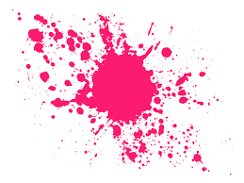
A Calm Jar

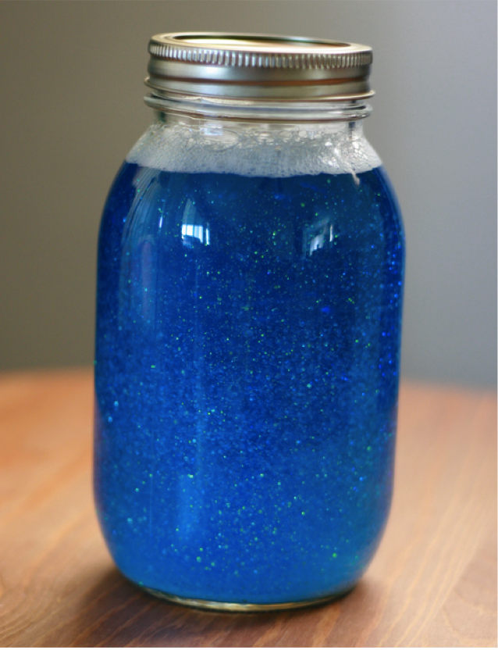

You will need:
Jar
Glitter
Water
Glue

Instructions:

Just mix 1 tablespoon of glitter glue, per 1 cup of hot water, add extra glitter (Use an extra small tub).

Emotion/Superhero Balloons
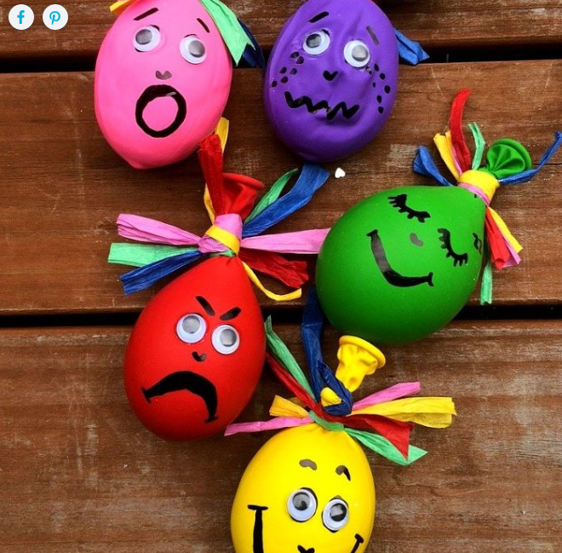

You will need:
Rice or Playdough – enough to fill your balloons.
As many latex balloons as you’d like (the larger ones make filling a little easier)
Some coloured string for crazy hair
Black permanent marker
Crazy eyes
Superglue (adults only to be trusted with this… and even then- careful!)
You can decorate your balloons however you like.

Instructions:
- Roll the playdough into little balls, as this makes it easier to stuff them into the balloons.
- Using both hands, pull open the balloon and whilst holding the opening, reach down towards the playdough balls and scoop them in, using your fingertips. You need to be quite forceful doing this… perhaps enlist the help of the little ones!
- Once you’re happy with how they’re filled, squeeze out as much air as possible and tie the balloon up.
- Rinse away any playdough that’s left in the opening.
- Using your coloured ribbon, string or raffia, tie this to the balloon for the crazy hair – as little or as much as you like!
- Flatten the balls slightly with the palm of your hand and then draw on your chosen expressions or emotions with the marker. If you are going to use crazy eyes, simply put small dots as a guide for where you’ll be gluing them on
- Working one by one, dot the superglue over the black dots of the eyes before attaching the crazy eyes of your choice.

Hair Gel Bags
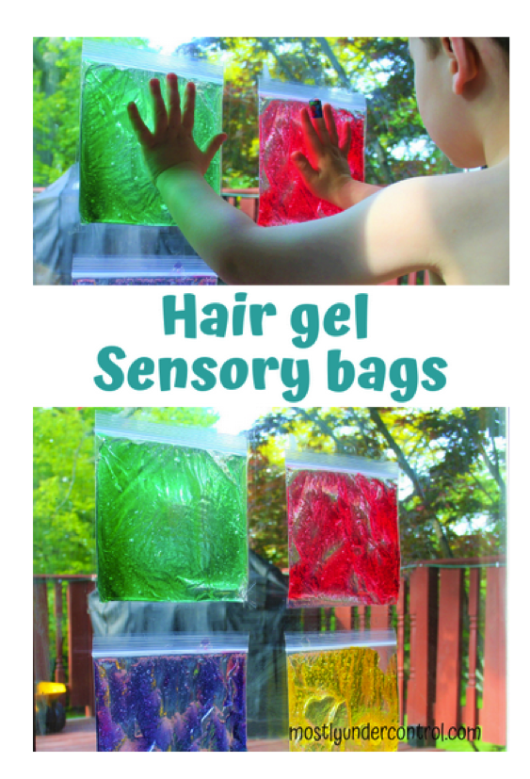

You will need:
Sandwich bags
Food colouring
Clear (or any colour) hair gel
Packing tape

Instructions:

- Squirt some hair gel into sandwich bags and add a few drops of food colouring.
- Then you let out all the extra air and zip it shut. Tape them up on the back door. The sun will look so cool shining through the colours!
- You could also add glitter, letters or whatever you want in the bags as long as you follow the steps above.

Toilet Paper Roll Squid

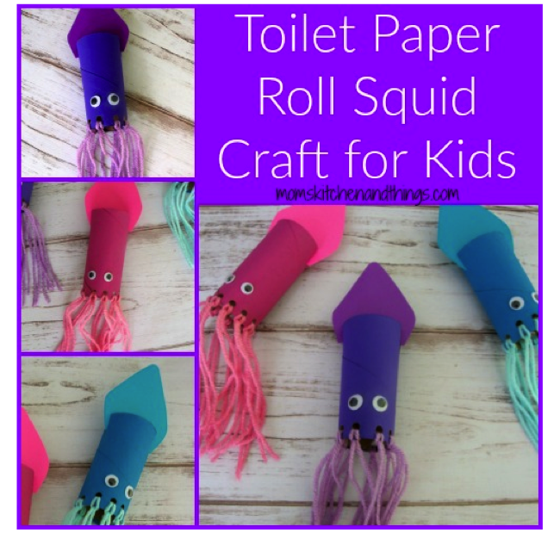

You will need:
Paint
Yarn (any material)
Toilet paper roll
Scissors
Hole punch
Pencil
Paint brush
Googly eyes
Card stock
Glue

Instructions:

- Paint the toilet paper roll. Punch 10 holes around the bottom & cut 2 slits (across from each other) in the top.
- Cut ten 12″ pieces of yarn & cut a rounded triangle out of the card stock.
- Attach the rounded triangle & yarn to the toilet paper roll.
- Glue on the googly eyes above the yarn.

Coloured Shaving Foam

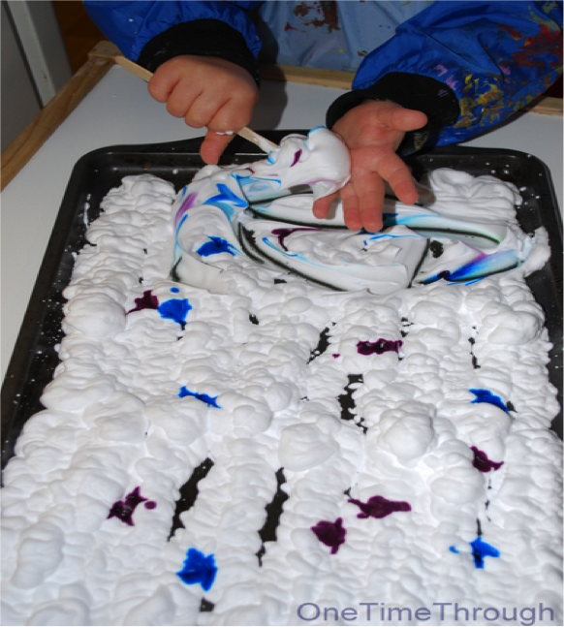

You will need:
Shaving Foam
Food Colouring
Tray or something to store foam.

Instructions:
- Squirt shaving foam onto tray.
- Add food colouring to the shaving foam.
- Enjoy playing with different toys or just getting your hands messy (food colouring could temporarily stain hands)

Sensory Moon Sand

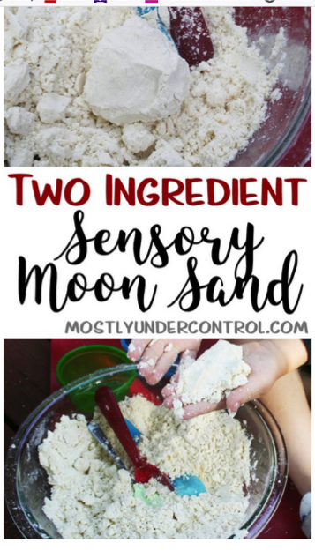

You will need:

Cups of all purpose flour

1/2 cup baby oil

Few drops of essential oil (optional)
Instructions:

Mix everything together with a spoon or your hands. I found it a lot easier to control with my hands. If you need it to be a little wetter, just add more baby oil.

Milk Bottle Elmer Elephant
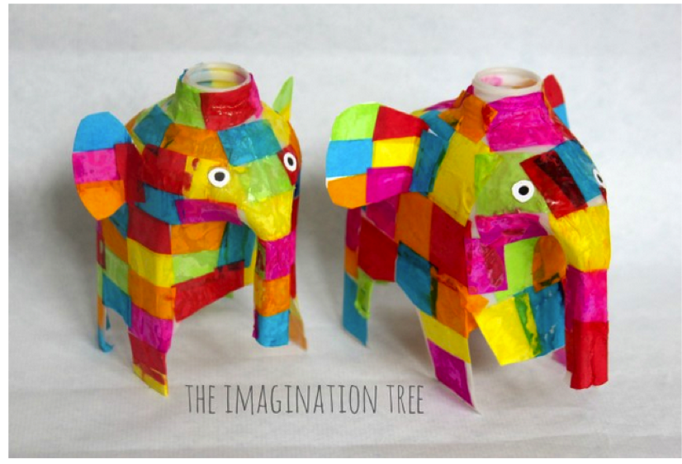

You will need:
Milk Bottle
Brightly coloured tissue paper cut into equal size and shape squares
PVA/ white glue and brushes/any glue.
White card
Black pen
Instructions:
- Stand the milk jug up and cut into it just below the handle. This will form the elephant’s trunk. Then cut off the entire bottom half of the jug and cut four legs into it, as well as a little tail. Done!
- Then set out tissue paper and glue and start to stick.
- Where some of the colours overlapped the colours occasionally bled into each other, but this looked lovely. Once they were covered they added another wash of glue over the top to make it dry hard and shiny. It didn’t take long at all, and then we came back to them to add ears and eyes.
- The ears were made by cutting equal sized pieces of white card into semi circles, with a tab at the bottom so we could bend it and glue onto the body. They stuck the colours onto the ears before we attached them, then we trimmed around the edges where it had overlapped.
- The eyes were simply white circles cut from card, with black pupils drawn with Sharpie marker
- All done and looking oh-so-adorable!

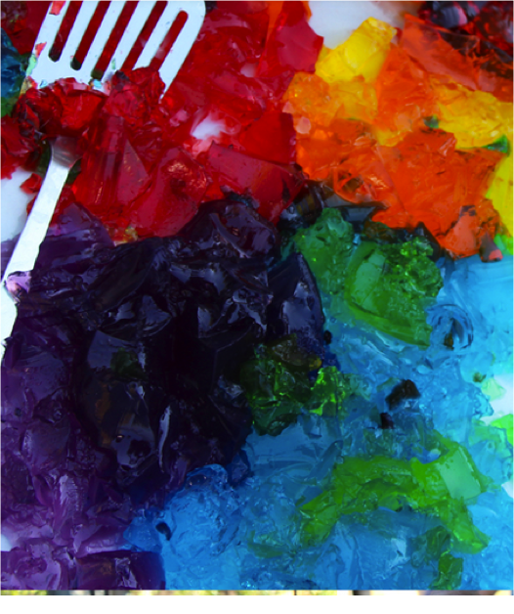
Coloured Jelly

You will need:
Different coloured jelly cubes.
Toys/letters/glitter
Tray or something to store.

Instructions:

- Break up different coloured jelly pieces.
- You can add anything to the jelly like glitter, pom poms, if you do add these do not eat the jelly.
- Hide letters, numbers, toys and have child find or make words once they find the letters.

Rainbow Rice
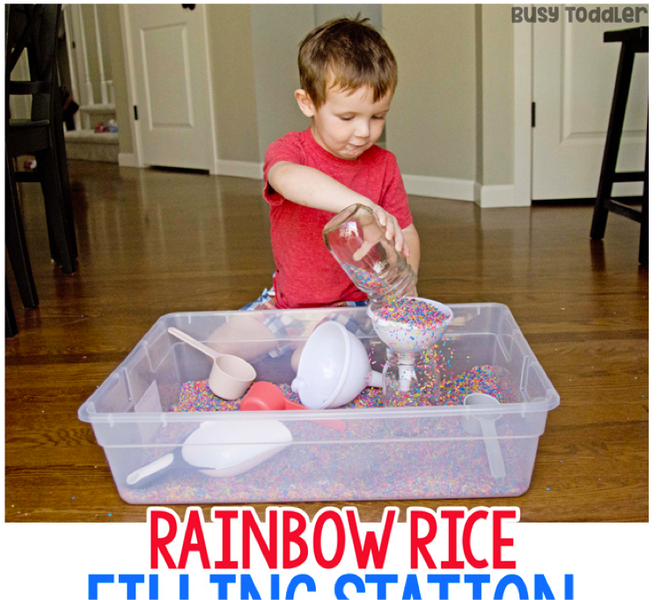

You will need:
1 cup of white rice
1 tablespoon of white vinegar
Food colouring
Tub to contain the rainbow rice
Sandwich bags/resalable containers
Instructions:
Mix this up in a zip-lock bag or resalable container, and lay it to dry on a paper plate. Repeat for as many colours as you want (the batch in these photos is 6 different colours). Leave to dry for one hour.

Rainbows

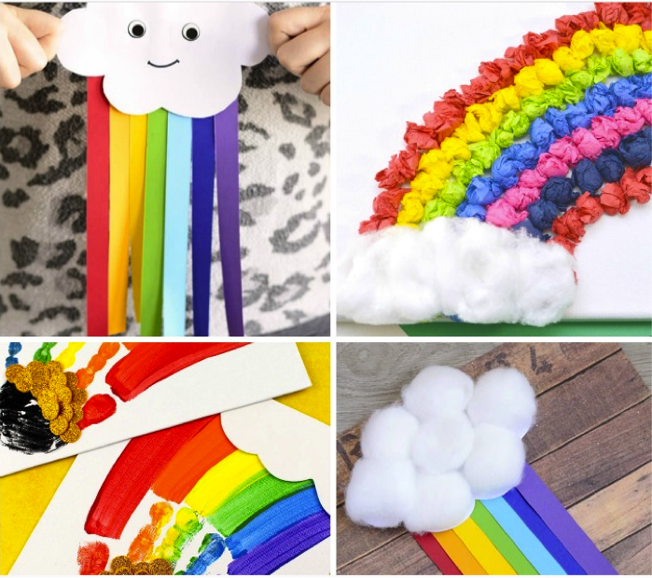

You will need:
Strips of coloured paper.
White paper.
Colours
Cotton wool.
Scissors
Glue.
Instructions:
- Cut a cloud shape from paper or create a cloud with cotton wool.
- Design your rainbow however you like, with scrunched up paper or cut stripes of paper and stick onto the cloud.

