
Cereal Necklace/Bracelet

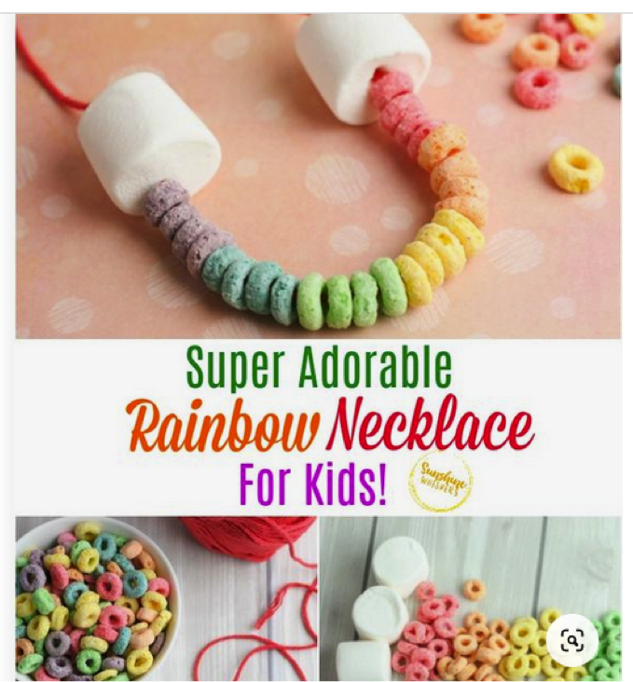

What you will need:
String or material to hold the cereal
Cereal
Any other decorative objects to add to your bracelet/necklace.

Instructions:
- Nice simple instructions take your string or whatever you’re using as your necklace/bracelet, thread your materials onto it.

Four Seasons Handprint Tree
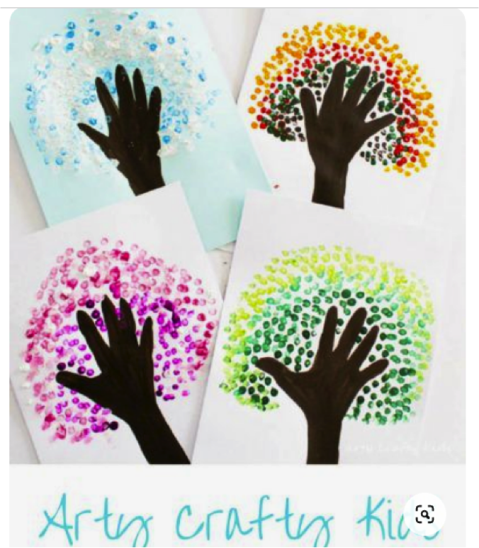

What you will need:
Paint
Paper
Colours

Instructions:
- Create the base of your tree on paper, using colours or paint.
- Then either with your fingers or hands use the different coloured paints to create the leaves and four seasons.

Easter Bunny Mask
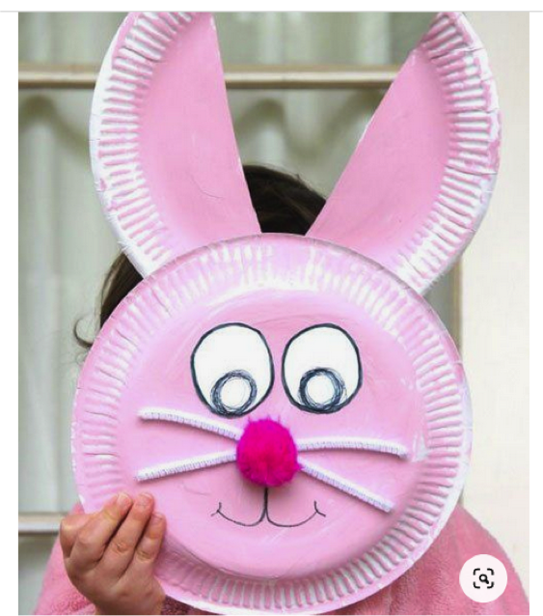

What you need:
Paper plates
Paint
Colours
String or anything to make nose and whiskers

Instructions:
- Using the paper plates cut one in half to make the ears.
- Paint both plates
- Add your bunny’s face

Rock Easter Eggs

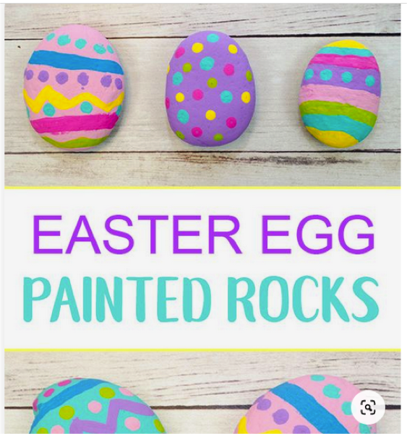

What you will need:
Rocks
Paint

Instructions:
- Simply pick some rocks from your garden and paint the rocks into some lovely Easter eggs.

Bunny Toilet Roll

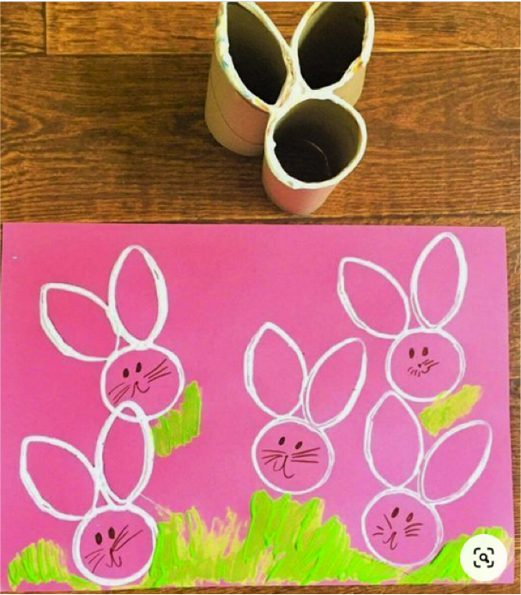

What you will need:
Toilet Roll
Paper
Paints
Glue/Sellotape

Instructions:
- Create the bunny shape with your toilet rolls and stick them together.
- Dip the bunny shape into your paint and print away.

Spring Chicks Egg Carton

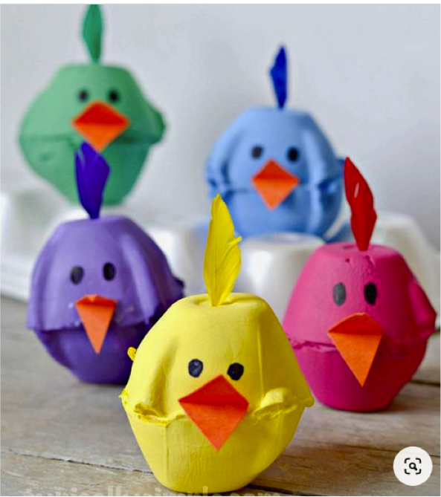

What you will need:
Paint or colours
Egg cartons
Scissors
Anything to decorate

Instructions:
- Carefully cut your egg cartons so they are single cartons. (Ask for an adults help)
- Paint your eggcup.
- Decorate to look like a cute chick.

Easter Card

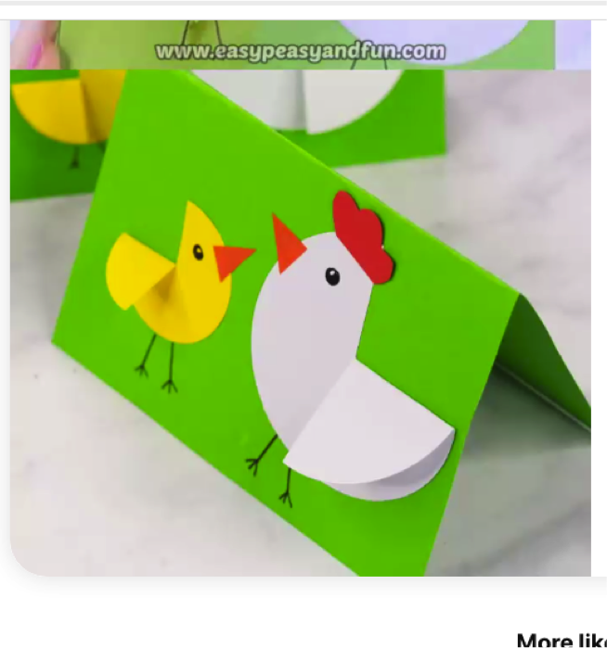

What you will need:
Card or paper
Anything to decorate your card

Instructions:
- Simply decorate your card however you like.

Design your own Easter Bonnet

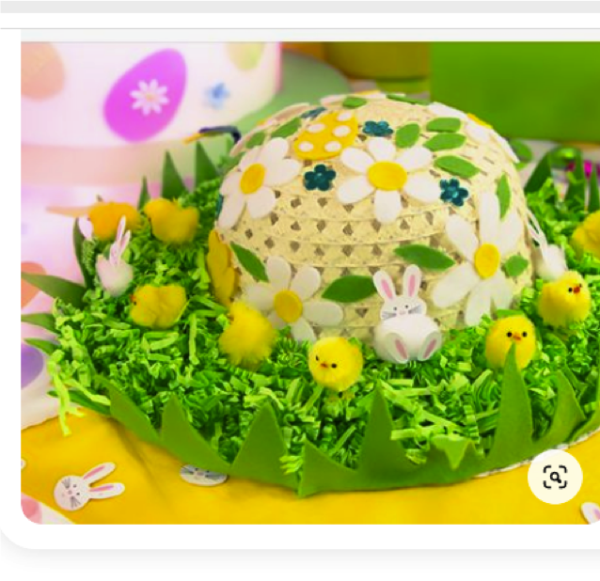

What you will need:
Paper
Colours

Instructions:
- Design on paper your Easter Bonnet! Make them bright and beautiful.

Carrot Cups
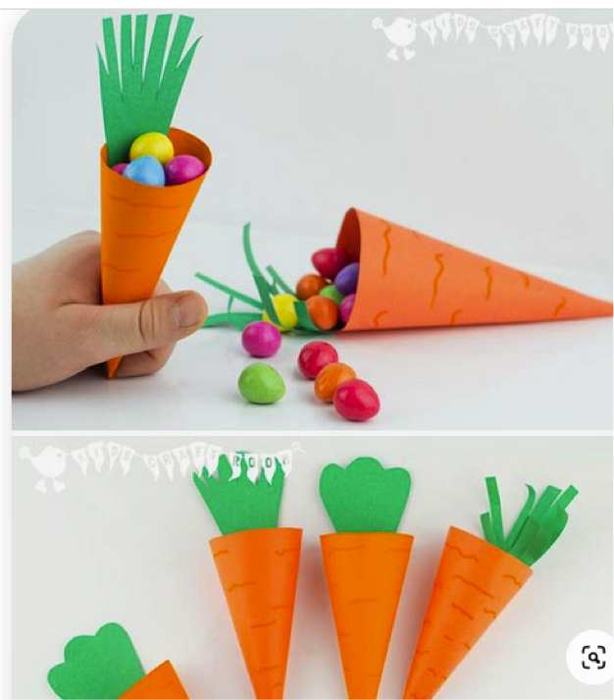

What you will need:
Paper or Card
Colours
Instructions:
- Using either coloured card or paper, which you can colour.
- Create a cone shape with your paper, and stick together.
- Cut grass for the top of your carrot cup.

Easter Bunting
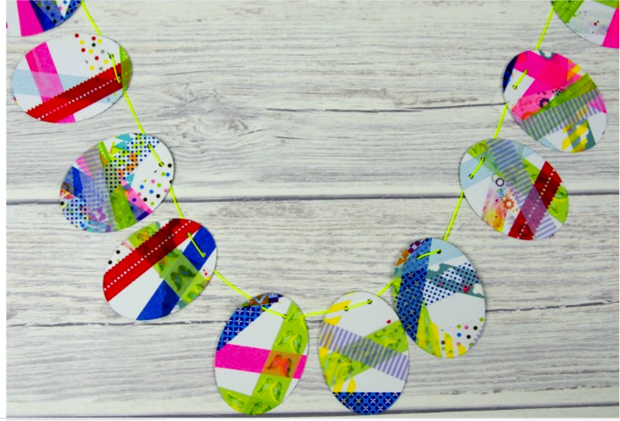

What you will need:
Paper
String
Anything to decorate

Instructions:
- Cut your Easter eggs out of your paper and decorate.
- Ask and adult to help you create a little hole to loop your string through.
- Hang your beautiful bunting up.

