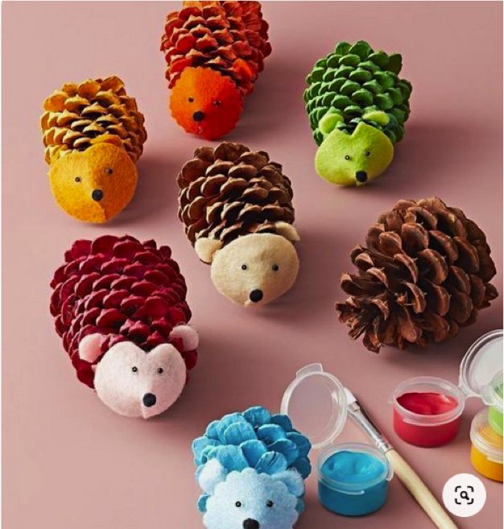
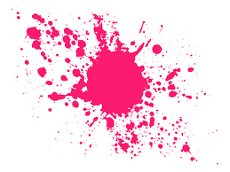
Cone Critters

What you need:
Pinecone
Paint
Material to make the face
Glue
Scissors
Instructions:
- Craft cute hedgehogs (or other animals) from pinecones. Cut a small circle of felt, or any material snip out a 90-degree-triangle wedge, and then overlap the two cut edges to glue into a cone shape.
- Once dry, glue to the tip of a plain or painted cone.
- Cut two smaller circles and attach with glue for ears. Finish with a small black pom-pom for a nose and small black beads for eyes.
- Tip: Use scissors or pinking shears to add personality to each hedgehog face. Ask an adult for help.

Bright Branches
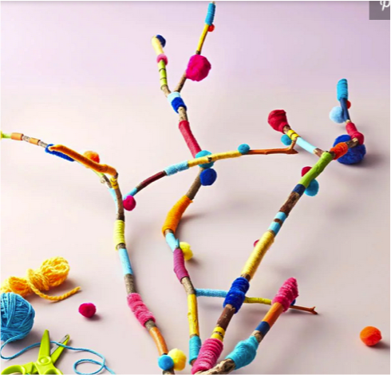

What you need
Branches
Any material to decorate branches
Paint
Instructions:
- This art project is extra brilliant because you can use up all the leftover craft supplies you have on hand. Select a medium-size branch for the base. Then, have kids wrap yarn, ribbon, and even pipe cleaners around the branch. Glue on pom-poms and other embellishments of their choosing.
- Tip: Paint stripes between the wrapped areas for extra colour

Leaf Painting

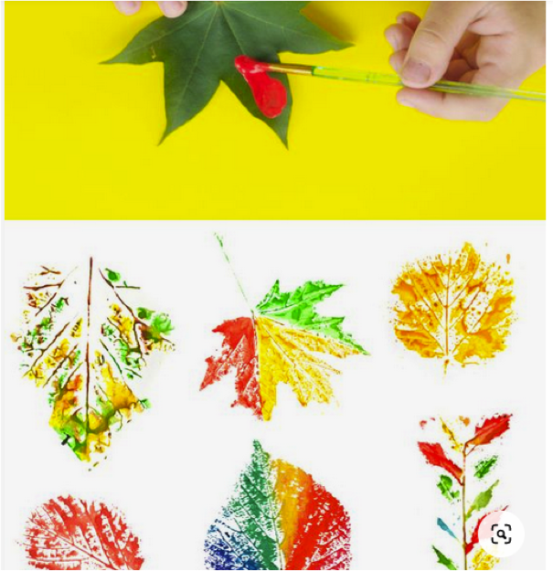

What you need:
Leaves
Paper
Paint
Paintbrush

Instructions:
- Collect leaves and choose your paper.
- Simply paint each leaf whichever colour you choose.
- Turn the leaf over and trace the painted side onto the paper.
- Be sure to make some beautiful patterns.

Butterfly Toilet Roll
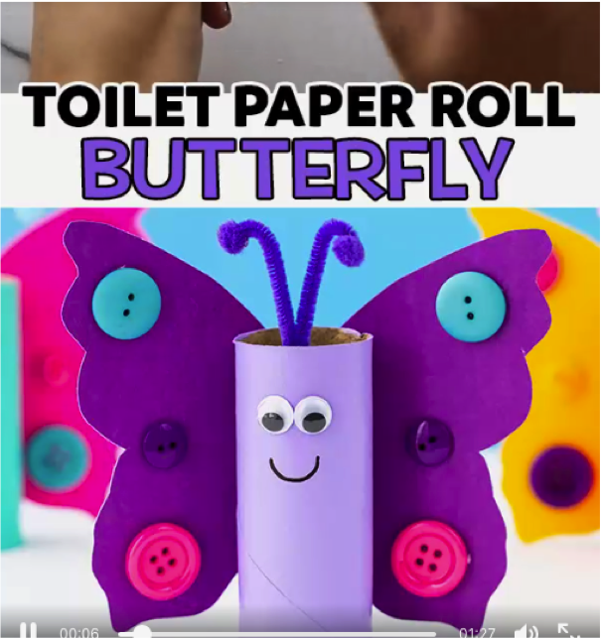

What you need:
Toilet Roll
Paint
Any materials to create your butterfly wings, and decorate.
Glue
Instructions:
- First create your butterfly wings, using any materials you have, paper, felt, any material.
- Decorate the wings.
- Paint your toilet roll. Wait for it to dry.
- With glue attach the wings onto the butterfly.

Peg Monsters

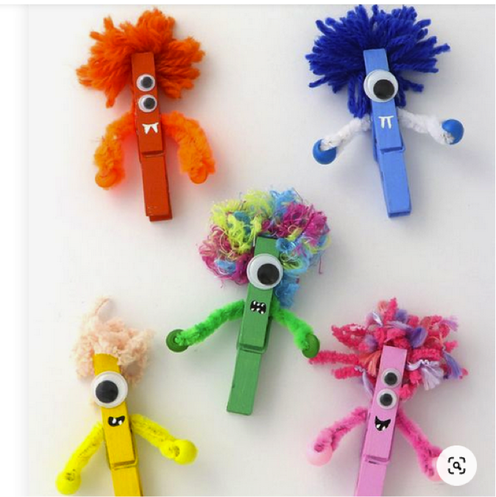

What you need:
Pegs
Paint/Colours
Anything to decorate hair and face.

Instructions:
- Taking a peg, paint the peg whichever colour you wish.
- Decorate the peg with whatever materials you have, you can always just use colours to add a face and some funky hair.

Sock Puppet

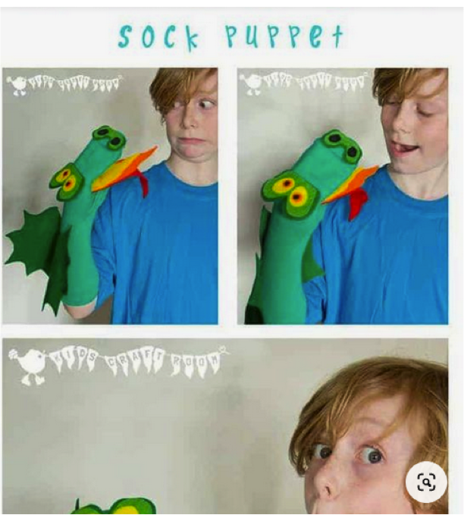

What you need:
Sock
Anything to design your sock puppet
Glue

Instructions:
- Pick a bright colourful sock.
- Design your sock however you like, either like the photo above, a dragon.
- I cannot wait to see your designs

Abstract Painting

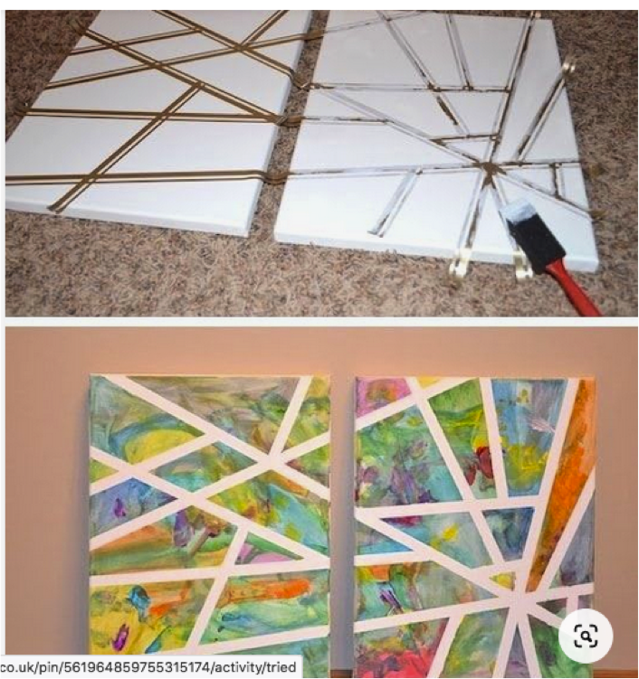

What you need:
Paper
Paint
Tape

Instructions:
- Draw out with a pencil where you want to stick your tape, to create a pattern.
- Stick your tape down, following your mapped out lines.
- Paint or colour the other sections of your paper, leaving your tape blank.
- Once dry, (if you used paint) peel off your tape, to reveal your amazing pattern

Family Handprint Keepsake
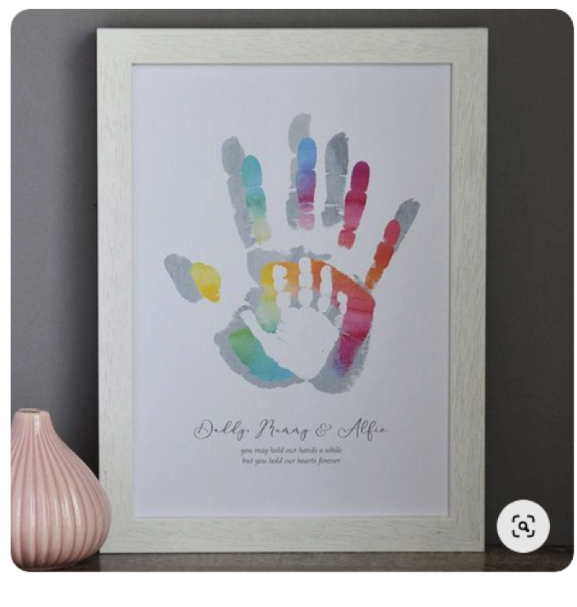

What you need:
Paper
Paint
Pen
Frame (if you want to frame it)

Instructions:
- Each family member, starting with the oldest prints his or her hand on the paper.
- Move down in age to the youngest, you can either print on top of each other (waiting for each hand to dry in between) or print next to one another using different colours.
- Add a little message in pen at the end.
- Add to a frame if you want to as a nice little keep sake.

