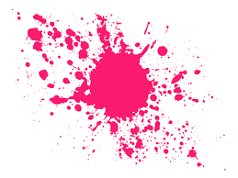
Bubble Wrap Art

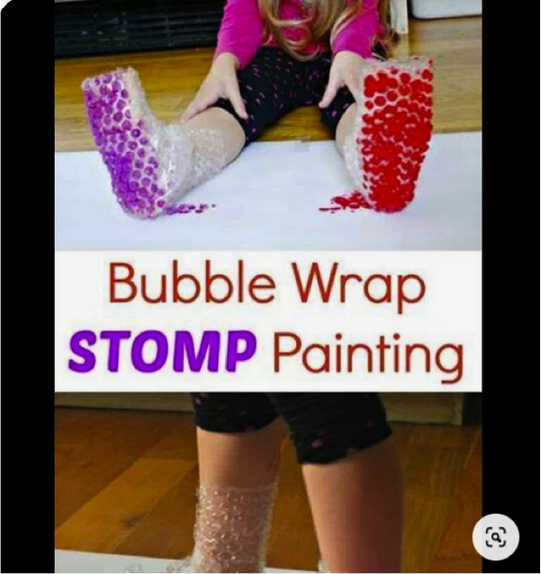

What you need:
Bubble Wrap
Paint
Paper

Instructions:
- Put you paper on the floor, a bigger piece is better for this task so you can walk, you can always attach paper together.
- Choose your paints and put the paint in something you can dip your feet/hands into.
- Attach the bubble wrap to your feet, or hands if you fancy.
- Enjoy creating fun patterns with your bubble wrap painting.

Sensory Break Cup
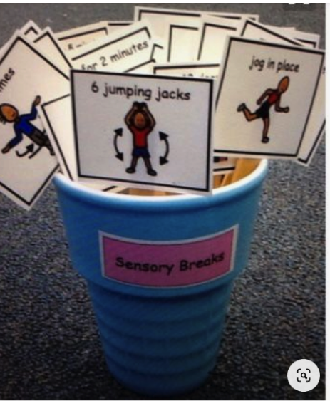

What you need:
Any object to store your ideas in
Pen
Paper/card
Scissors

Instructions:
- This task is great for sensory breaks and fun activities to break up the day.
- Sit together and come up with different exercises, you can pick one, two, three out each time to put a sequence together, just to burn off some extra energy.
- Cut your paper into squares.
- Once you have decided write you exercise on card, draw a picture and make it bright and colourful.
- Place in cup.

Pom Pom Drop
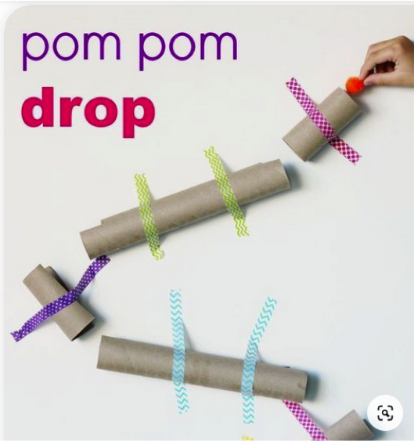

What you need:
Toilet Rolls
Tape, blu tac
Pom Pom/Small ball, or anything you can roll into a small ball shape.

Instructions:
- Choose the obstacle you want to create with your tubes, (if you don’t want them directly stuck on a wall, you could attach them to card or paper first and then stick on a flat surface.)
- Stick your tubes in the position you have chosen.
- Drop the pom pom ball through and see if your obstacle works.
- You can adapt this, start smaller and build up to add rounds and challenges.

Feel and Find Box

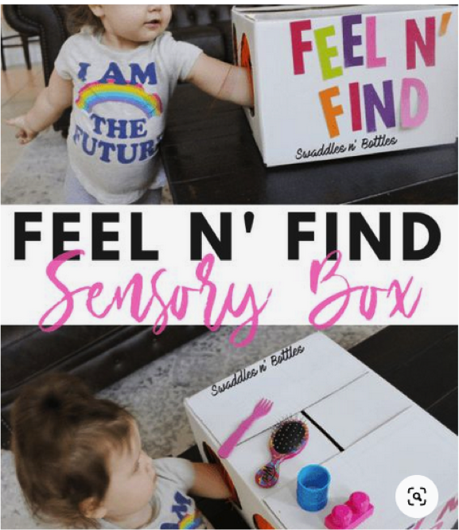

What you need:
A box
Any objects to use in the feel and find box, sensory things are good. (Hairbrushes, anything with textures.)
You can also use foods or tastes, things like jelly, ice cream.
You can also decorate your box.

Instructions:
- Create hand holds in your box, if the box or object your using means you can’t cut, simply put a cover over to disguise objects.
- Get your child/children to describe what they feel before they guess.

Water Gun Paint
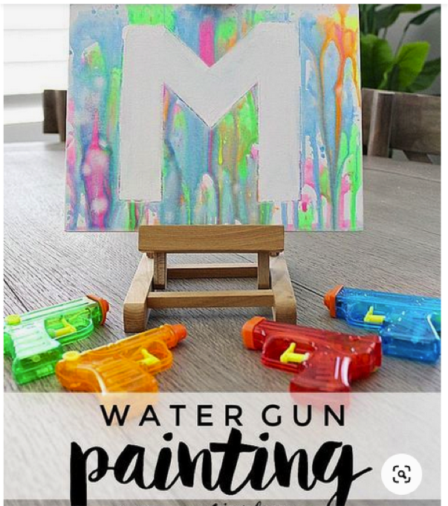

What you need:
Water gun
Paint
Water
Paper/Canvas
Anything old to protect wherever you choose to do this activity, I’d advise the garden, but still cover to protect anything.

Instructions:
- Fill your gun with paint, go off the consistency, if you want to add water first to make it easier for your paint to go in, do so, if not add the paint and add a few drops of water.
- Use water guns with an easy pull back and release or they will need adult help. (Make sure you’re not worried if the guns get wrecked, they should be easy to clean, but just in case, don’t use expensive ones.)
- Put your paper either on the floor or hang it.
- Cover and protect any area you need too, and let the fun begin.
- Create exciting patterns with different coloured paint.

Fluffy Cloud Dough
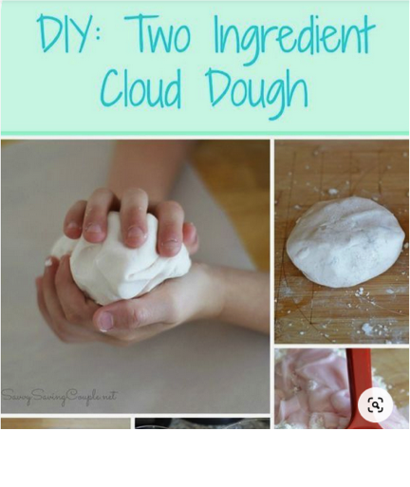

What you need:
1 cup of thick and creamy hair conditioner
2 cups of cornstarch
Food colouring or sparkles *both optional
Baking paper and an airtight container
Gloves for hands

Instructions:
- In a large bowl, mix your conditioner, and cornstarch. If the mixture is too sticky add a little bit more cornstarch.
- If the mixture is too dry, add a bit more conditioner.
- The dough should be non-stick, stretchy, and pliable.
- Divide it up by how many kids are playing, and by what colours/sparkles they want.
- It will last 2-3 weeks if kept in an airtight bag or tupperware.

Sensory Walk
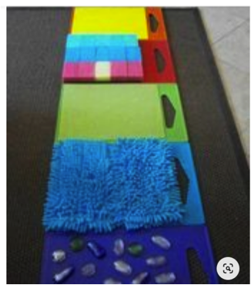

What you need:
Different materials for your children to walk on. Sponges, any soft material, bubble wrap. You could also use foods, jelly, ice cream, if you were using foods I’d advise going outside.
Boards, black bags, trays… anything to put your materials/food on that can also easily be cleaned up.

Instructions:
- Create your boards/black bin walk by laying your black bin or boards down.
- Make a pathway with the different products/objects/foods you have decided to use.
- Let your child/children walk and feel the different textures, they could move across it in different ways. With foods be very careful they don’t slip, so I would stick to standing and slowly walking in the different foods, if possible put them in large trays for children to step in and out of.

Ice Sensory Play
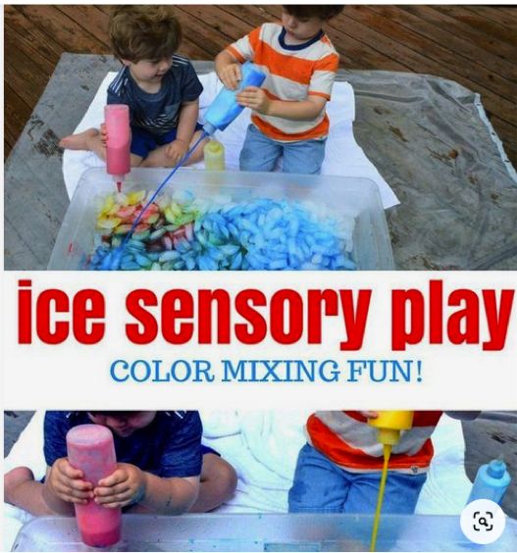

What you need:
Ice
Paint
Tray
Towels
Paint Brushes

Instructions:
- If you have ice trays make trays of ice, or if its easier you can buy cheap bags of ice.
- Put into a big tray or something to contain the ice for when it changes to water.
- Squirt the paint into the ice and use the paintbrushes to mix around. It’s great for sensory.

Gelli Baff Eye Spy
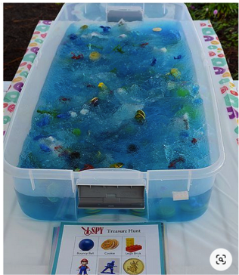

What you need:
Gelli Baff… I have used this with my little boy (he’s 18m) I would advise buying this as its great and so easily to dispose of. Here is a link to ordering gelli baff, you can always order off different places but I would say it’s worth it.
Use different objects in the Gelli Baff; play eye spy by creating a list of objects and your child has to find them in the gelli baff.
It’s such a great sensory task. You can of course also use it in the bath and it dilutes back into water.
Instructions:
- Make your Gelli Baff in a tray or the bath following instructions.
- Add the different objects, play eye spy.

